Practical No. 6

Aim : Implement K-Means clustering/ hierarchical clustering on sales_data_sample.csv dataset. Determine the number clusters using the elbow method.
Code :

In [82]:
import pandas as pd
import numpy as np
import seaborn as sns
import matplotlib.pyplot as plt

In [83]:
from sklearn.cluster import KMeans
from sklearn.decomposition import PCA
from sklearn.preprocessing import StandardScaler

In [84]:
df = pd.read_csv("sales_data_sample.csv", encoding ="Latin-1")

In [85]:
df.head()

Out[85]:
ORDERNUMBER | QUANTITYORDERED | PRICEEACH | ORDERLINENUMBER | SALES | OR

0 10107 30 95.70 2 2871.00
1 10121 34 81.35 5 2765.90

2 10134 41 94.74 2 3884.34
3 10145 45 83.26 6 3746.70
4 10159 49 100.00 14 5205.27 1

5 rows × 25 columns
C C

In [86]:
df.shape

Out[86]: (2823, 25)

In [87]:
df.describe()

Out[87]: | ORDERNUMBER |  | QUANTITYORDERED | PRICEEACH | ORDERLINENUMBER
 | count | 2823.000000 | 2823.000000 | 2823.000000 | 2823.000000 | 2823.0
 | mean | 10258.725115 | 35.092809 | 83.658544 | 6.466171 | 3553.8
 | std | 92.085478 | 9.741443 | 20.174277 | 4.225841 | 1841.8
 | min | 10100.000000 | 6.000000 | 26.880000 | 1.000000 | 482.1
 | 25% | 10180.000000 | 27.000000 | 68.860000 | 3.000000 | 2203.4
 | 50% | 10262.000000 | 35.000000 | 95.700000 | 6.000000 | 3184.8
 | 75% | 10333.500000 | 43.000000 | 100.000000 | 9.000000 | 4508.0
 | max | 10425.000000 | 97.000000 | 100.000000 | 18.000000 | 14082.8
C C

In [88]:
df.info()
<class 'pandas.core.frame.DataFrame'> RangeIndex: 2823 entries, 0 to 2822
Data columns (total 25 columns):
# Column Non-Null Count Dtype

- ORDERNUMBER 2823 non-null int64
- QUANTITYORDERED 2823 non-null int64
- PRICEEACH 2823 non-null float64
- ORDERLINENUMBER 2823 non-null int64
- SALES 2823 non-null float64
- ORDERDATE 2823 non-null object
- STATUS 2823 non-null object
- QTR_ID 2823 non-null int64
- MONTH_ID 2823 non-null int64
- YEAR_ID 2823 non-null int64
- PRODUCTLINE 2823 non-null object
- MSRP 2823 non-null int64
- PRODUCTCODE 2823 non-null object
- CUSTOMERNAME 2823 non-null object
- PHONE 2823 non-null object
- ADDRESSLINE1 2823 non-null object
- ADDRESSLINE2 302 non-null object
- CITY 2823 non-null object
- STATE 1337 non-null object
- POSTALCODE 2747 non-null object
- COUNTRY 2823 non-null object
- TERRITORY 1749 non-null object
- CONTACTLASTNAME 2823 non-null object
- CONTACTFIRSTNAME 2823 non-null object
- DEALSIZE 2823 non-null object dtypes: float64(2), int64(7), object(16)
memory usage: 551.5+ KB

In [89]:
df.dtypes

Out[89]: | ORDERNUMBER  QUANTITYORDERED PRICEEACH  ORDERLINENUMBER | int64  int64 float64 int64
 | SALES  ORDERDATE STATUS  QTR_ID  MONTH_ID YEAR_ID  PRODUCTLINE MSRP  PRODUCTCODE CUSTOMERNAME PHONE  ADDRESSLINE1 ADDRESSLINE2 CITY  STATE  POSTALCODE COUNTRY  TERRITORY  CONTACTLASTNAME CONTACTFIRSTNAME DEALSIZE  dtype: object | float64 object object int64 int64 int64 object int64 object object object object object object object object object object object object object
In [90]: | df.isnull().sum()
Out[90]: | ORDERNUMBER | 0
 | QUANTITYORDERED | 0
 | PRICEEACH | 0
 | ORDERLINENUMBER | 0
 | SALES | 0
 | ORDERDATE | 0
 | STATUS | 0
 | QTR_ID | 0
 | MONTH_ID | 0
 | YEAR_ID | 0
 | PRODUCTLINE | 0
 | MSRP | 0
 | PRODUCTCODE | 0
 | CUSTOMERNAME | 0
 | PHONE | 0
 | ADDRESSLINE1 | 0
 | ADDRESSLINE2 | 2521
 | CITY | 0
 | STATE | 1486
 | POSTALCODE | 76
 | COUNTRY | 0
 | TERRITORY | 1074
 | CONTACTLASTNAME | 0
 | CONTACTFIRSTNAME | 0
 | DEALSIZE  dtype: int64 | 0
In [91]: | df_drop = [  'ORDERNUMBER', | 'ORDERDATE', 'STATUS', 'PRODUCTLINE', 'PRODUCTCODE',
'CUSTOMERNAME', 'PHONE', 'ADDRESSLINE1', 'ADDRESSLINE2',
'CITY', 'STATE', 'POSTALCODE', 'COUNTRY', 'TERRITORY',

'CONTACTLASTNAME', 'CONTACTFIRSTNAME', 'DEALSIZE'
]

In [92]:
df_cleaned = df.drop(df_drop,axis=1)

In [93]:
df.isnull().sum()

Out[93]:

In [94]:
ORDERNUMBER 0
QUANTITYORDERED 0
PRICEEACH 0
ORDERLINENUMBER 0
SALES 0
ORDERDATE 0
STATUS 0
QTR_ID 0
MONTH_ID 0
YEAR_ID 0
PRODUCTLINE 0
MSRP 0
PRODUCTCODE 0
CUSTOMERNAME 0
PHONE 0
ADDRESSLINE1 0
ADDRESSLINE2 2521
CITY 0
STATE 1486
POSTALCODE 76
COUNTRY 0
TERRITORY 1074
CONTACTLASTNAME 0
CONTACTFIRSTNAME 0
DEALSIZE 0
dtype: int64
df.dtypes

Out[94]: | ORDERNUMBER  QUANTITYORDERED PRICEEACH  ORDERLINENUMBER | int64  int64 float64 int64
 | SALES | float64
 | ORDERDATE | object
 | STATUS | object
 | QTR_ID | int64
 | MONTH_ID | int64
 | YEAR_ID | int64
 | PRODUCTLINE | object
 | MSRP | int64
 | PRODUCTCODE | object
 | CUSTOMERNAME | object
 | PHONE | object
 | ADDRESSLINE1 | object
 | ADDRESSLINE2 | object
 | CITY | object
 | STATE | object
 | POSTALCODE | object
 | COUNTRY | object
 | TERRITORY | object
 | CONTACTLASTNAME | object
 | CONTACTFIRSTNAME | object
 | DEALSIZE | object
 | dtype: object

In [95]:
df['COUNTRY'].unique()

Out[95]:

In [96]:

Out[96]:

In [97]:

Out[97]:

In [98]:

In [99]: In [100… In [101…

In [102… In [103…
df.drop('ORDERDATE', axis = 1, inplace=True)
array(['USA', 'France', 'Norway', 'Australia', 'Finland', 'Austria', 'UK',
'Spain', 'Sweden', 'Singapore', 'Canada', 'Japan', 'Italy',
'Denmark', 'Belgium', 'Philippines', 'Germany', 'Switzerland', 'Ireland'], dtype=object)
df['PRODUCTLINE'].unique()
array(['Motorcycles', 'Classic Cars', 'Trucks and Buses', 'Vintage Cars', 'Planes', 'Ships', 'Trains'], dtype=object)
df['DEALSIZE'].unique()
array(['Small', 'Medium', 'Large'], dtype=object)
productline = pd.get_dummies (df['PRODUCTLINE']) Dealsize = pd.get_dummies (df['DEALSIZE'])
df = pd.concat([df, productline, Dealsize], axis=1)
df = pd.concat([df, productline, Dealsize], axis=1)
df_drop = ['COUNTRY', 'PRODUCTLINE', 'DEALSIZE']
df = df.drop(df_drop, axis =1 )
df [ 'PRODUCTCODE'] = pd. Categorical (df [ 'PRODUCTCODE']).codes

In [104…
df.dtypes

Out[104…

In [105…

In [106…
# Elbow method
distortions = [] K = range(1, 11)

for k in K:
kmeanModel = KMeans(n_clusters=k, random_state=42)
kmeanModel.fit(scaled_data) # <<--- use scaled numeric data
distortions.append(kmeanModel.inertia_)
ORDERNUMBER int64
QUANTITYORDERED int64
PRICEEACH float64 ORDERLINENUMBER int64
SALES float64
STATUS object
QTR_ID int64
MONTH_ID int64
YEAR_ID int64
MSRP int64
PRODUCTCODE int8
CUSTOMERNAME object
PHONE object
ADDRESSLINE1 object
ADDRESSLINE2 object
CITY object
STATE object
POSTALCODE object
TERRITORY object
CONTACTLASTNAME object CONTACTFIRSTNAME object
Classic Cars bool
Motorcycles bool
Planes bool
Ships bool
Trains bool
Trucks and Buses bool
Vintage Cars bool
Large bool
Medium bool
Small bool
Classic Cars bool
Motorcycles bool
Planes bool
Ships bool
Trains bool
Trucks and Buses bool
Vintage Cars bool
Large bool
Medium bool
Small bool
dtype: object
# Scale numeric data
scaler = StandardScaler()
scaled_data = scaler.fit_transform(df_cleaned)

In [107…
plt.figure(figsize=(16,8))
plt.plot(K, distortions, 'bx-') plt.xlabel('K')
plt.ylabel('Distortion')
plt.title('The Elbow Method showing the optimal k') plt.show()

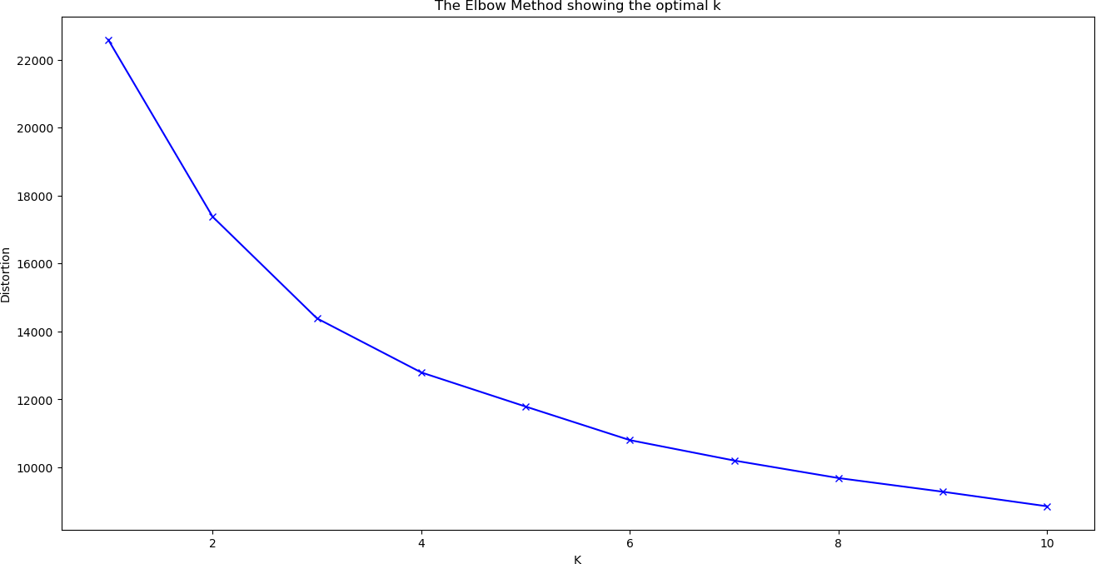

In [108… In [110…
x_train.shap
x_train = df.values
Out[110… (2823, 41)

In [112… In [114…
scaler = StandardScaler()
x_train_scaled = scaler.fit_transform(x_train)
x_train = df_cleaned.select_dtypes(include=['int64', 'float64'])

In [115…
# Fit KMeans with 3 clusters (example)
model = KMeans(n_clusters=3, random_state=2) model.fit(x_train_scaled)

Out[115…

KMeans(n_clusters=3, random_state=2)
i ?
s
KMean
▾

In [116…
predictions = model.predict(x_train_scaled) df_cleaned["Cluster"] = predictions

In [117…
print(df_cleaned.head())

pca = PCA(n_components=2)
reduced_X = pd.DataFrame(pca.fit_transform(x_train_scaled),
columns=['PCA1', 'PCA2'])

# Add cluster labels
reduced_X['Cluster'] = predictions

# Plot clusters
plt.figure(figsize=(8,6))
plt.scatter(reduced_X['PCA1'], reduced_X['PCA2'], c=reduced_X['Cluster'], cmap='rainbow')
plt.xlabel('PCA1') plt.ylabel('PCA2')
plt.title('Customer Segmentation using KMeans (PCA Visualization)') plt.show()
 |  | QUANTITYORDERED |  | PRICEEACH | ORDERLINENUMBER | SALES | QTR_ID | MONTH_ID \
0 |  | 30 |  | 95.70 | 2 | 2871.00 | 1 | 2
1 |  | 34 |  | 81.35 | 5 | 2765.90 | 2 | 5
2 |  | 41 |  | 94.74 | 2 | 3884.34 | 3 | 7
3 |  | 45 |  | 83.26 | 6 | 3746.70 | 3 | 8
4 |  | 49 |  | 100.00 | 14 | 5205.27 | 4 | 10
 |  | YEAR_ID | MSRP | Cluster
 | 0 | 2003 | 95 | 0
 | 1 | 2003 | 95 | 1
 | 2 | 2003 | 95 | 2
 | 3 | 2003 | 95 | 2
 | 4 | 2003 | 95 | 2
In [119…

